Address:
Pavilion Gardens,
Buxton

Car parking:
Off Burlington Rd

Buses:
Market Place

Trains:
Buxton Station
(5 mins walk)
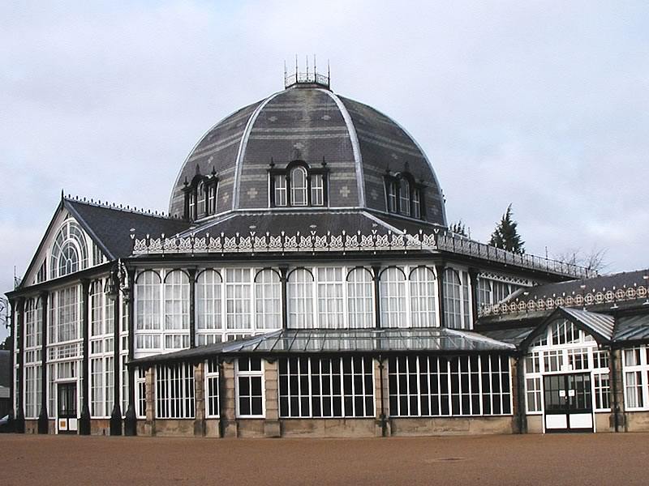

Buxton – Pavilion Gardens
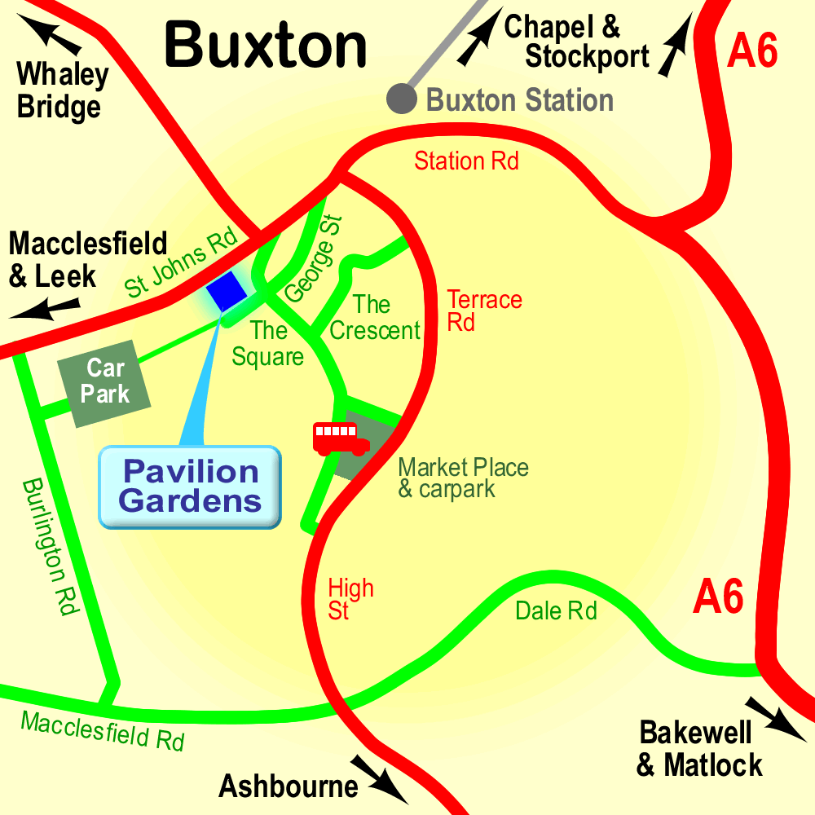

High Peak CVS
Unit 1a Bingswood Trading Estate,
Whaley Bridge, High Peak. SK23 7LY
Telephone 01663 735 350
Email hello@highpeakcvs.org.uk
Web www.highpeakcvs.org.uk


All venues used by High Peak CVS for training and meetings are accessible
by wheelchair users and have accessible toilets.

Copies of venue sheets available at highpeakcvs.org.uk/venues

