Address:
High St,
Chapel-en-le-Frith

Car parking:
Adjoining

Buses:
High St

Trains:
Chapel Station
(20 minutes walk)
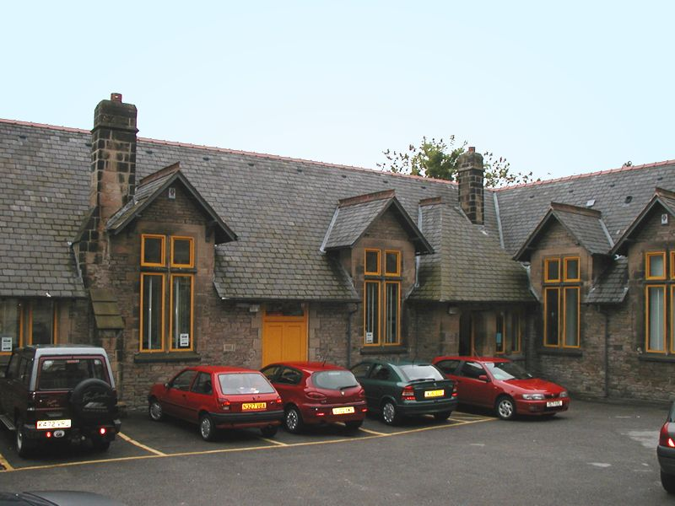

Youth Centre - Chapel
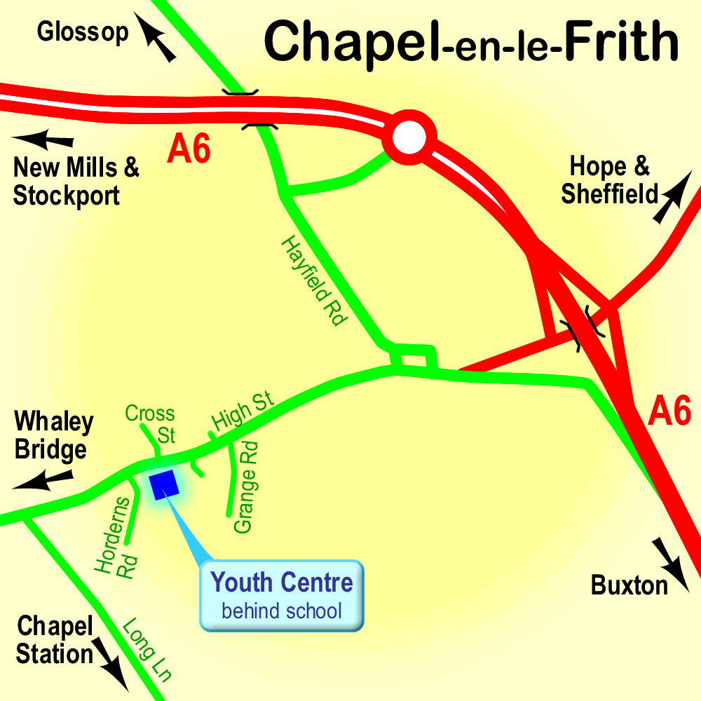

High Peak CVS
Unit 1a Bingswood Trading Estate,
Whaley Bridge, High Peak. SK23 7LY
Telephone 01663 735 350
Email hello@highpeakcvs.org.uk
Web www.highpeakcvs.org.uk


All venues used by High Peak CVS for training and meetings are accessible
by wheelchair users and have accessible toilets.

Copies of venue sheets available at highpeakcvs.org.uk/venues

