Address:
Market St,
Glossop

Car parking:
Off Victoria St
(pay and display)

Buses:
High Street West

Trains:
Glossop Station
(10 minutes walk)
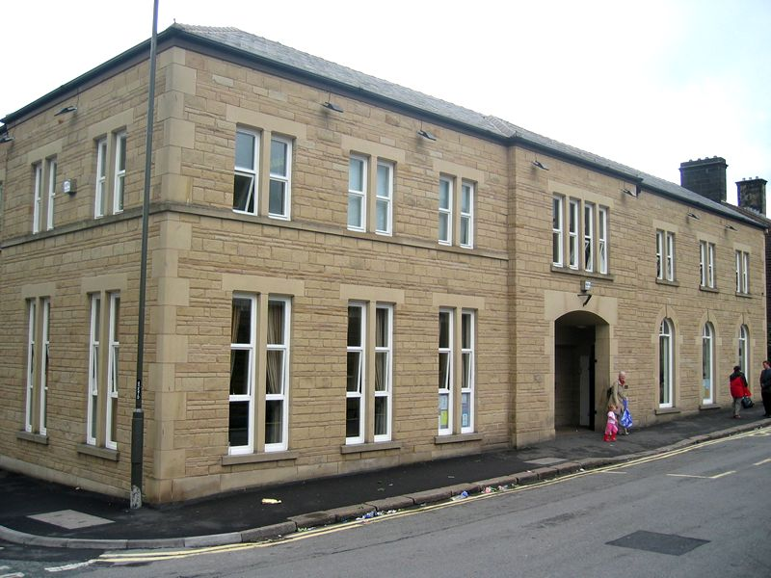

Bradbury House - Glossop
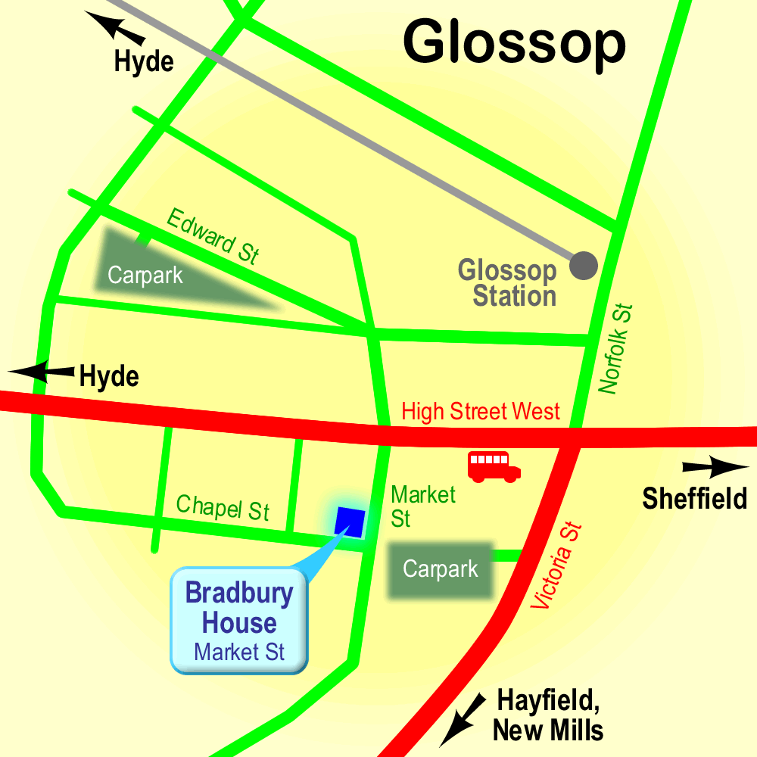

High Peak CVS
Unit 1a Bingswood Trading Estate,
Whaley Bridge, High Peak. SK23 7LY
Telephone 01663 735 350
Email hello@highpeakcvs.org.uk
Web www.highpeakcvs.org.uk


All venues used by High Peak CVS for training and meetings are accessible
by wheelchair users and have accessible toilets.

Copies of venue sheets available at highpeakcvs.org.uk/venues

