Address:
Hall St,
New Mills

Car parking:
At rear and front

Buses:
Market St / Union Rd

Trains:
Central Station (10 mins) Newtown Station (20 mins)

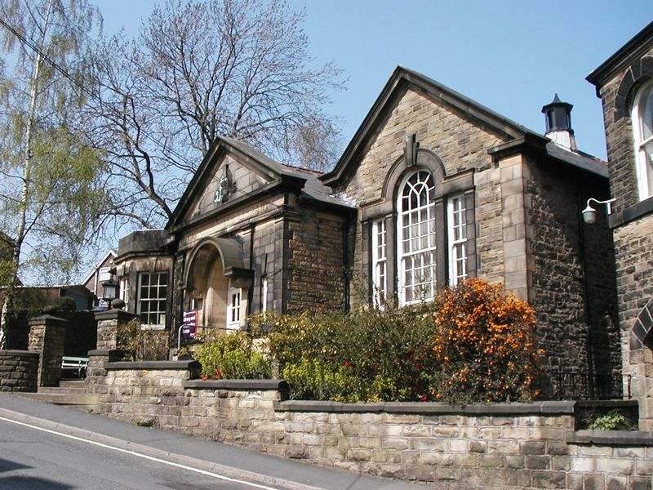

New Mills – Library Lecture Room

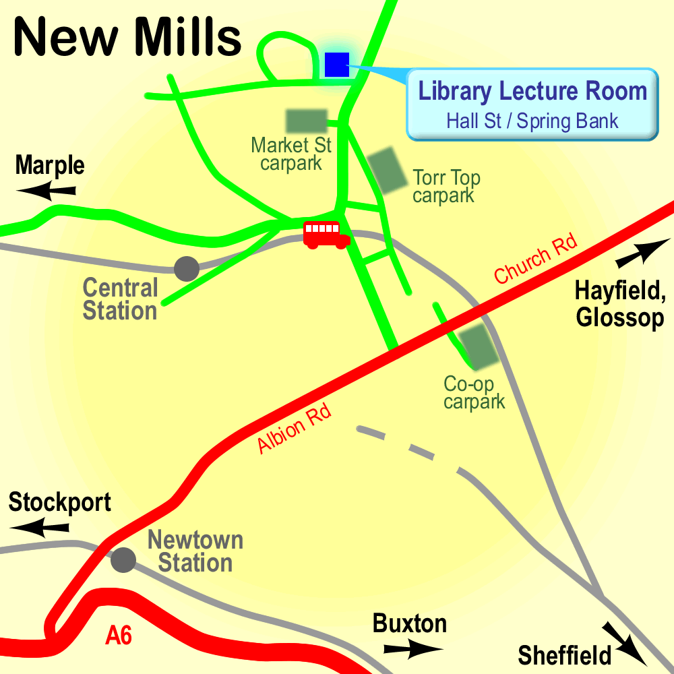

High Peak CVS
Unit 1a Bingswood Trading Estate,
Whaley Bridge, High Peak. SK23 7LY
Telephone 01663 735 350
Email hello@highpeakcvs.org.uk
Web www.highpeakcvs.org.uk


All venues used by High Peak CVS for training and meetings are accessible
by wheelchair users and have accessible toilets.

Copies of venue sheets available at highpeakcvs.org.uk/venues

