Address:
33 Union Rd,
New Mills

Car parking:
At rear or Torr Top
Car park (pay & display)

Buses:
Top Union Rd & Albion Rd

Trains:
Central Station (5 mins) Newtown Station (10 mins)
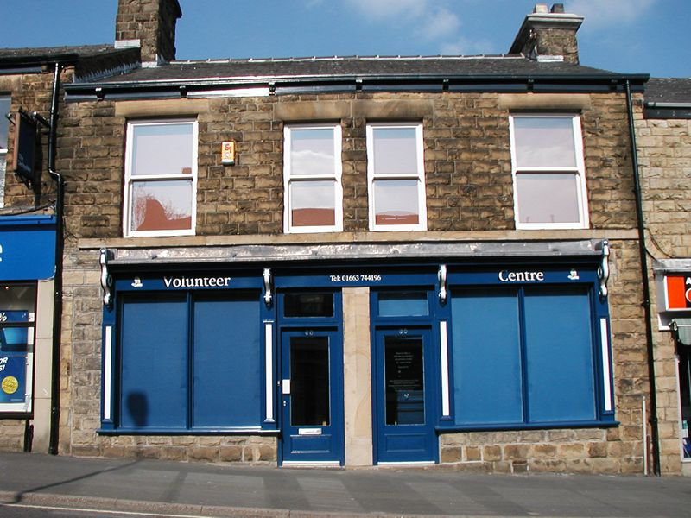

New Mills – Volunteer Centre
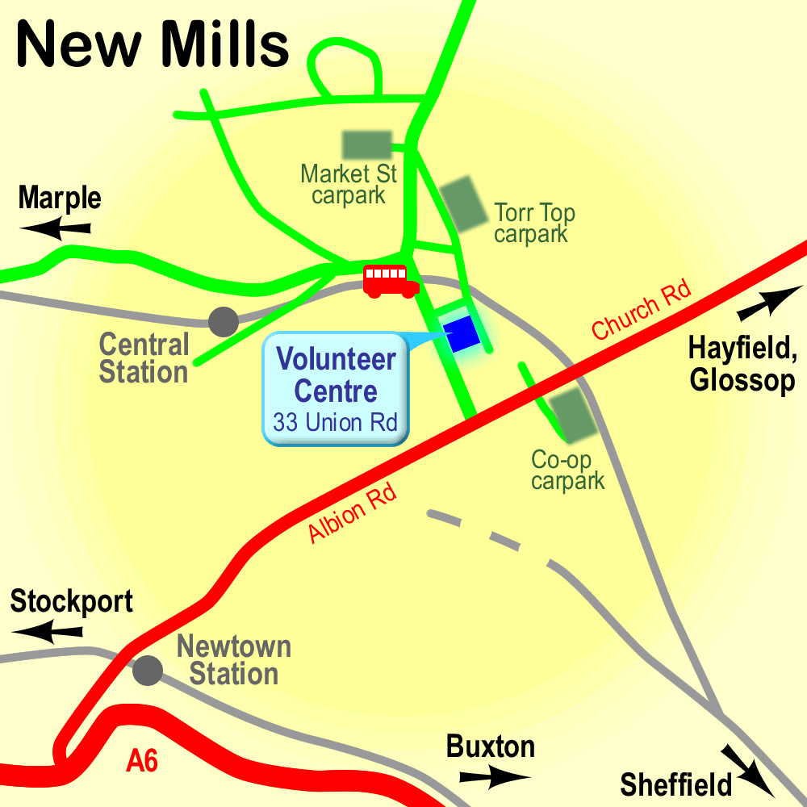

High Peak CVS
Unit 1a Bingswood Trading Estate,
Whaley Bridge, High Peak. SK23 7LY
Telephone 01663 735 350
Email hello@highpeakcvs.org.uk
Web www.highpeakcvs.org.uk


All venues used by High Peak CVS for training and meetings are accessible
by wheelchair users and have accessible toilets.

Copies of venue sheets available at highpeakcvs.org.uk/venues

