Address:
Footsteps,
Market St
Whaley Bridge

Car parking:
Nearby

Buses:
Buxton Rd, near station

Trains:
Whaley Bridge Station
(2 mins walk)
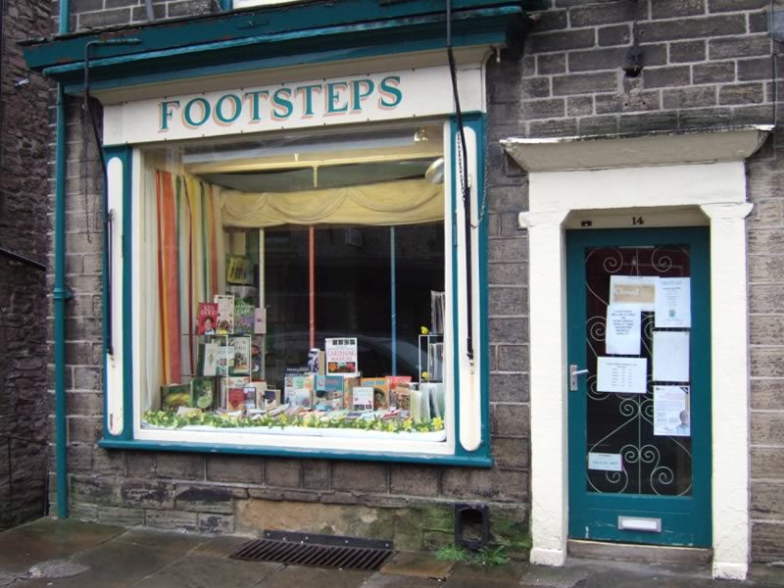

Whaley Bridge – Footsteps
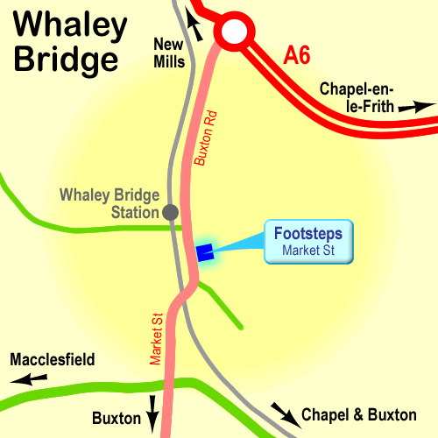

High Peak CVS
Unit 1a Bingswood Trading Estate,
Whaley Bridge, High Peak. SK23 7LY
Telephone 01663 735 350
Email hello@highpeakcvs.org.uk
Web www.highpeakcvs.org.uk


This venue is not fully accessible by wheelchair users.

Copies of venue sheets available at highpeakcvs.org.uk/venues

