Address:
Uniting Church,
Market St
Whaley Bridge

Car parking:
Ar rear

Buses:
Buxton Rd, near station

Trains:
Whaley Bridge Station
(5 mins walk)
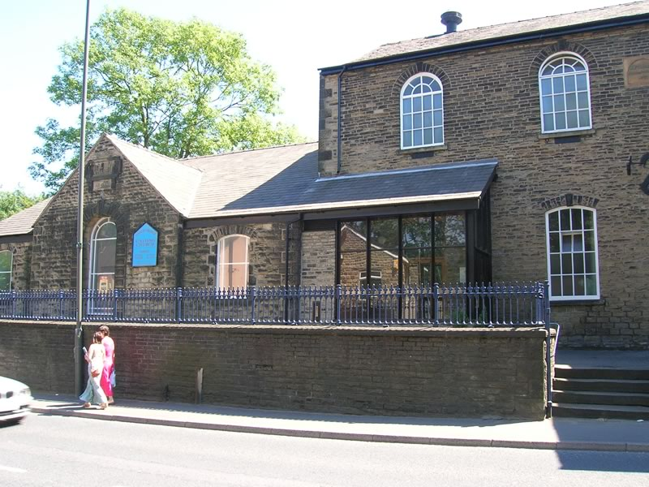

Whaley Bridge – Uniting Church
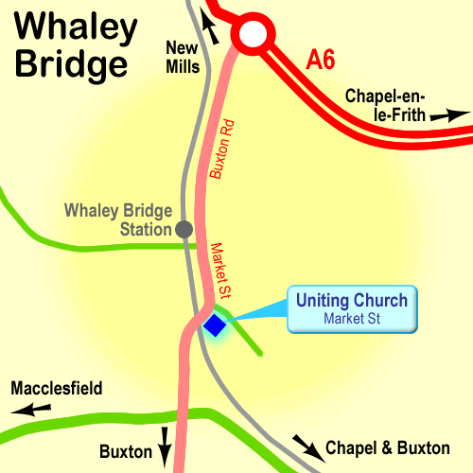

High Peak CVS
Unit 1a Bingswood Trading Estate,
Whaley Bridge, High Peak. SK23 7LY
Telephone 01663 735 350
Email hello@highpeakcvs.org.uk
Web www.highpeakcvs.org.uk


All venues used by High Peak CVS for training and meetings are accessible
by wheelchair users and have accessible toilets.

Copies of venue sheets available at highpeakcvs.org.uk/venues

